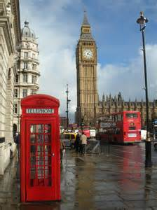
Year 1
Easter Homework

In the summer term our new topic will be … Hooray! Let’s go on holiday!

During this topic we will be learning about ‘Going on Safari’ and ‘London’.
Your Easter challenge is to carry out research into both topics (you can use a computer or visit your local library and use their non-fiction books).

I would then like you to create a poster or booklet! This can be 2 sheets of A4 or a piece of A3 (card or paper).

On your poster (or booklet) you can include important information about both places as well as flags, maps, drawings, photographs and if you have happen to visit London over the Easter break you include some of your souvenirs.

Use a range of sentence openers … Most / Many / Sometimes / Usually / Did you know /

Please allow your child the opportunity to write for themselves. If they need your support then help them to sound out words or use a dictionary to find the correct spelling (please don’t write it on a piece of paper for them to copy up!).
The project is due back in school on Monday 20th April (not before, please).

Have a wonderful Easter break and don’t eat too many eggs!
Miss Phillips

