How do you play?
You'll need a grown-up to play with.
You'll also need a number line from 1-20, like the one above. You can print some off here.
The grown-up chooses two numbers in this grid and either multiplies or divides them.
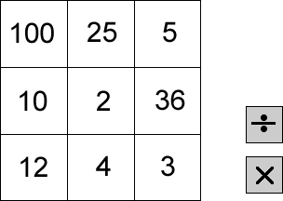
They then mark the answer to the calculation on the number line. You then choose two numbers and either × or ÷ , and mark that number in a different colour on the number line.
If the answer is too big or too small to be marked on the number line, the player misses a go. The winner is the person to get four marks in a row with none of their opponent's marks in between.
What good ways do you have of winning the game?
Does it matter if you go first or second?
How are you deciding which number to aim for next?
Can you find a winning strategy?
Notes for grown-ups
This game gives children the opportunity to estimate answers to calculations in a motivating context and gives plenty of practice in multiplication and division. Playing strategically involves higher-order thinking and the need to think ahead.
Easier version: you could use a calculator, and/or adapt the grid and numberline.
Harder version: children can be encouraged to tweak the game and to try out their new version. For example, they might change the number line, the grid of numbers, the operations, the number of numbers needed to win...

