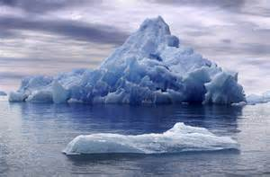
Dear Year 1 Polar Experts,

I need your help!
The polar ice caps are melting which will be devastating news for our polar animals.
The animals need the ice to live on; if it melts they will be left with only the ocean and no land.
Your challenge is …
Find a way of slowing the ice melting process.
I have sent you a selection of our most endangered species in blocks of ice. Can you explore the different materials and find which one helps the animals stay frozen for longer.

I have included everything I think you need in the box.

I am looking forward to reading your experiment write ups.
Thank you

Professor Ice Blast

