**100 Books To Read In Year 3 and 4**

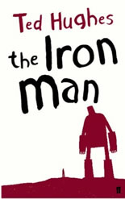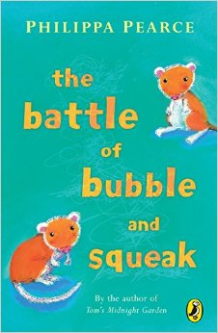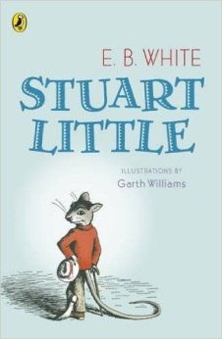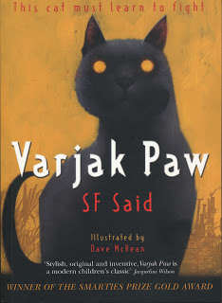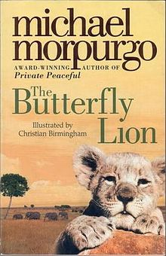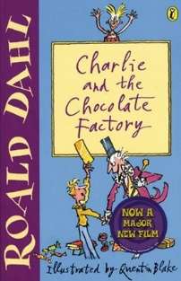

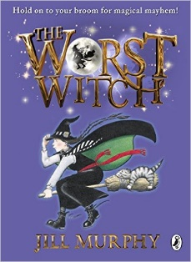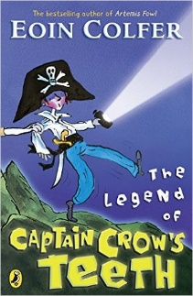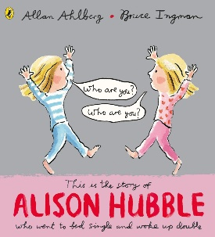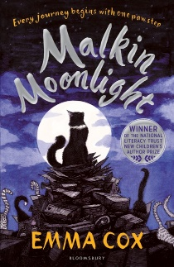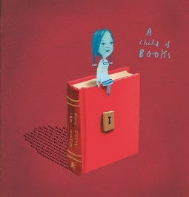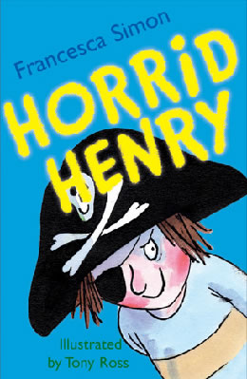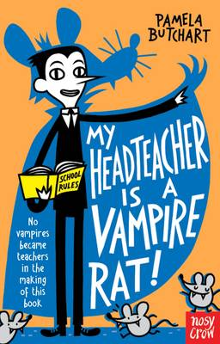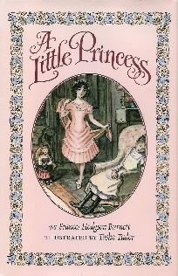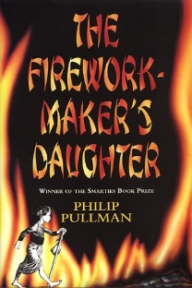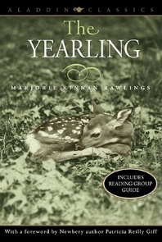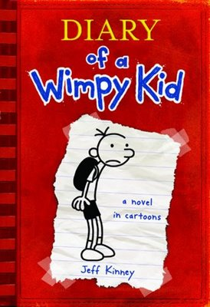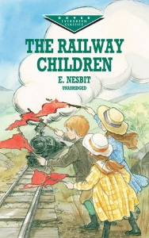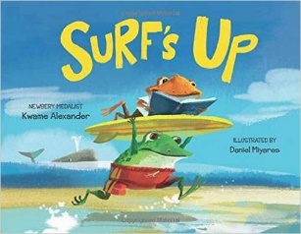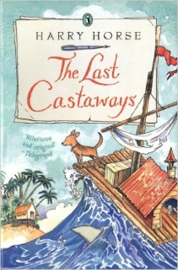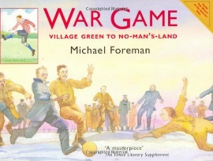

War Game

Michael Foreman

The Worst Witch

Jill Murphy

The Legend of Captain Crow’s Teeth

Eoin Colfer

Alison Hubble

Allan Ahlberg and Bruce Ingham

Malkin Moonlight

Emma Cox

A Child Of Books

Oliver Jeffers

Horrid Henry

Francesca Simon

My Headteacher is a Vampire Rat

Pamela Butchart

The Iron Man

Ted Hughes

A Little Princess

Frances Hodgson Burnett

The Firework-Maker’s Daughter

Phillip Pullman

The Yearling

Marjorie Kinnan Rawlings

The Railway Children

E Nesbit

Diary Of A Wimp Kid

Jeff Kinney

Surf’s Up

Kwame Alexander

The Last Castaways

Harry Horse

The Battle of Bubble and Squeak

Phillips Pearce

Stuart Little

E B White

Varjak Paw

S F Said

The Butterfly Lion

Michael Morpurgo

Charlie and the Chocolate Factory  
Roald Dahl